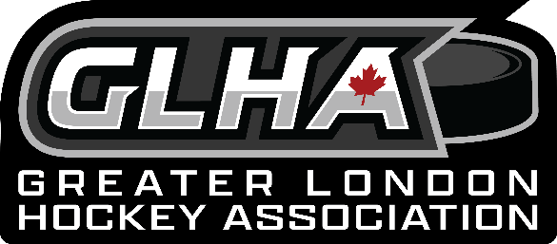
Greater London Hockey Association
Meeting
January 18,2024
Attendance: Jack Boyce, Jay Dillman (Mustangs, North London), Frank Rapski, Mike Rivard (West London), John Brochu, Darcy Goettling, Lisa Ford, Luisa Gould, Guest Laura Brown
- Welcome/Call to Order – called the Meeting to order at 7:02 pm
- Confirmation of Agenda
- Laura Brown- Jack welcomed Laura Brown from the OHF, she will be discussing the Diversity Project that was started by Justin Hoffer. There are funds available from the Legacy funds and she is willing to do the marketing for us. Laura will take the lead in this; Jack asked all associations to send their volunteers to Jack a Luisa so we can get the ball rolling on this initiative. She talked about the possibility of adding it to the Bauer first shift program. Jack expressed that we need to get this up and running sooner than later, it will strengthen our registration numbers.
- Setting up Registration meeting - Luisa will sit with Shawn Phibbs and Don Drown to update the spreadsheet for this season and we will meet on teams with registrars and ice convenors and presidents to get the registration process going for the next season. Jack has asked Mike to find out if there is a price increase, and he will ask at the alliance level as well.
- Constitution – Luisa sent out quotes to the four different lawyers for the upgrading of the constitution based on the recommendation from the meeting at the OHF, with the necessary changes to ONCA. Frank thinks we do not have to do it based that we are not for profit, this is incorrect all Not for profit organization must complete this. It not just us, its all of us at OMHA, Alliance, OHF – all of Ontario must complete by OCT 2024, Jack will be discussing this at the Alliance semi annual meeting.
- Reminder Alliance Semi Annual Meeting January 27, 2024

- Approval of prior meeting minutes: Motion to approve the minutes from November – Lisa and Darcy seconded, all in favour.
- Reports.
- Chairperson – Jack is in discussions with centres in gaining some more registrations for our associations. It’s a process and the communication has just begun.
- Rep Council-. We have not had a rep council meeting, there is a meeting coming in January. We reviewed the Dressing room policy and Jack will be going back to the Alliance to get further clarification.
- Concerns about policing this, and repercussions from this.
- London Referee Group – a suggestion about the green arm band for the younger referees. Jack will address with the LRG.
- Treasurer – sent the bank statements, not much change in the accounts, a cheque came from Alliance for 246,00 – email Traci Pauli as he not sure what the cheque is for.
- Jack addressed the payment needed for sportsheadz, Frank has not received these payments, Jack will forward the email to him.

- Committee Reports.
- Community Hockey League- preparing for the Alliance championships, and playoffs are organized.
- Juvenile has been added to the alliance house league championship.

- Mustangs – nothing really to report, things going smoothly.

- Round Table/New Business
- North
- U9 group going to outlaw group in Glencoe, - this has been brought up in the past and we cannot do this as we need coaches and players. We do not want to lose players forever.
- Discussion about the BB Tryouts in the spring, presented us with pro and cons for this, Jack asked us to address it with our boards and bring back to this table for a decision on this.
- Discussion about paid employment for board members and questions about voting etc. Jack addressed this as well to bring back to the boards and ask the following questions Which positions do they think they want paid or should be paid, should we do a GLHA paid positions and make it one organization to help the issue of no having volunteers etc. There are some positions that get paid in some organizations and some that do not.
- Bandits – all volunteers no paid employees
- North – discussion Ice convenor paid.
- West London – Ice convenor, treasurer, and registrar
- Oakridge – Treasurer paid, although she almost quit on Darcy and Ice convenor.
- Meetings – Next board meeting will be online – February 15 Teams Luisa will send the link and set up meeting.
- Adjournment – motion to adjourn the meeting Darcy and Lisa and all approved at 8:45 pm

